Assignment 14 Spring 2025
Heat Equation 1
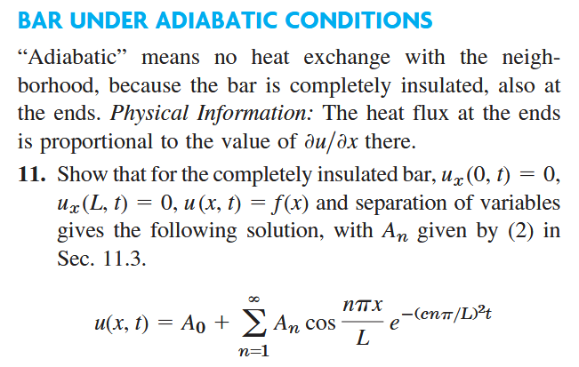
Find the temperature in Prob. 11 with L = π, c = 1, and f (x) = cos(2x).

Heat Equation 2
Solution to the heat equation where the ends of the bar are kept at 0⁰C is given by
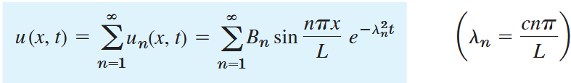
With 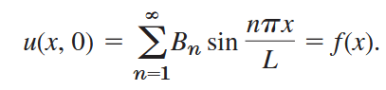, where 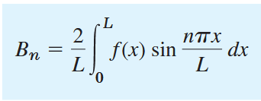.
Write down the solution u(x, t) when f (x) = sin (0.1πx) and c = 1, L = 10.
Heat Equation 3
Solve the heat equation for a very long bar using Fourier transforms and the method of convolution to show that
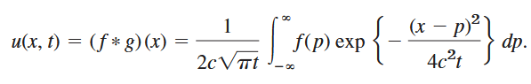
Hint: This is exactly what we did in class, so you just need to go through the notes.

